FACILITY FUNCTIONING

Any Ebola and Marburg facility is characterized by two main areas:
(associated with green color) the low-risk or staff zone, exclusively dedicated to the staff
(associated with red color) the high-risk zone, where patients receive treatment and care and where the presence of the pathogen is expected.
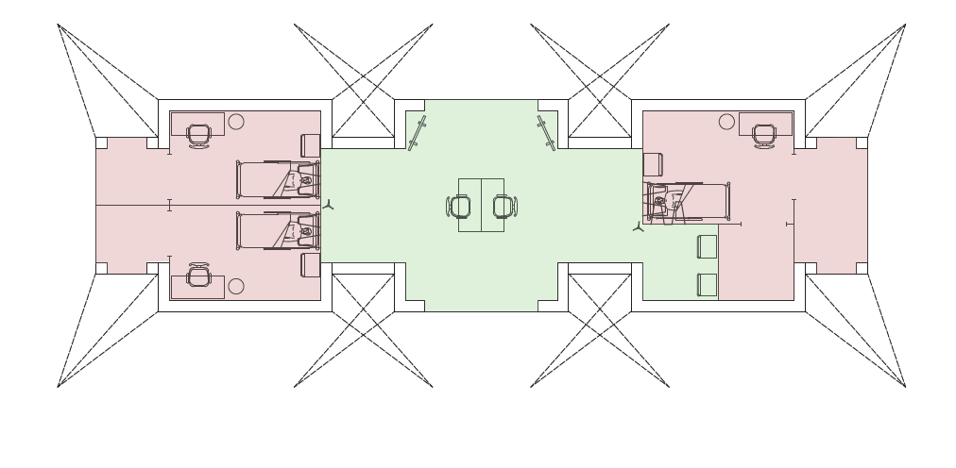

minimum ETC with IDTM
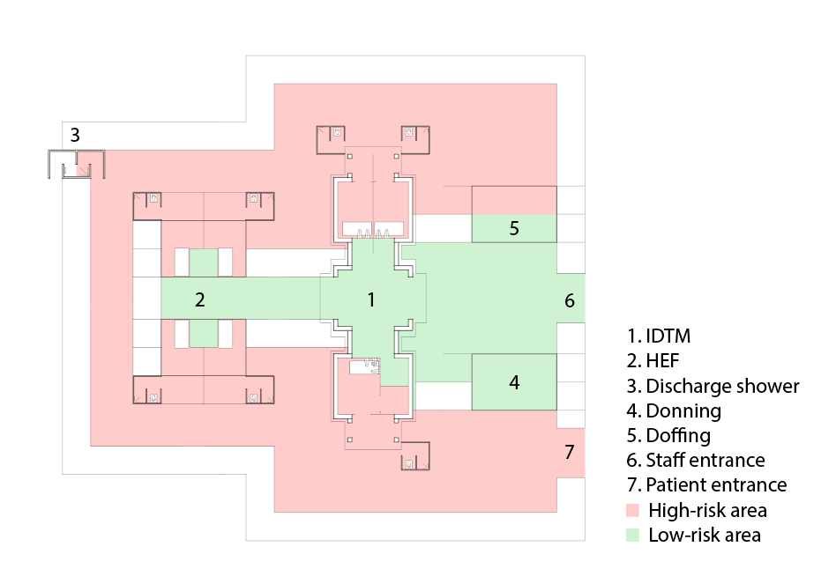
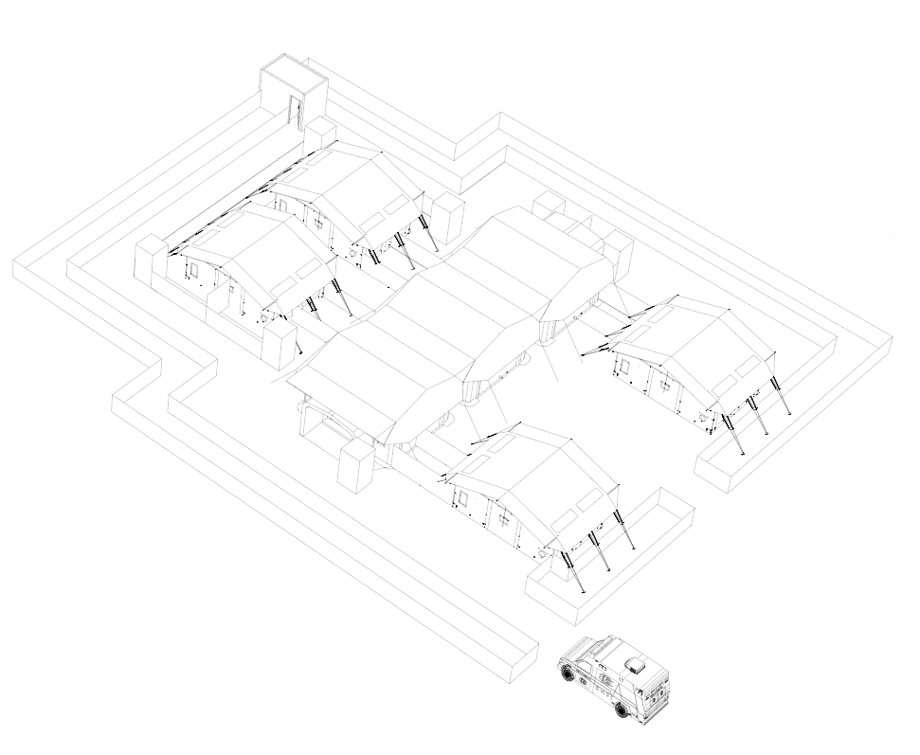
useful links:
- Case definition – Ebola Disease Outbreak Toolbox
- Essential principles for treatment center design –Ebola and Marburg Treatment Centres: Facility Design and Construction Standards for Preparing for and Responding to Outbreaks
- Filo TREAT clinical management course –FiloTREAT course
- Infection prevention and control guidelines – WHO guidelines for infection prevention and control for Ebola and Marburg diseases.

SOP cleaning disinfection:

The coordinator briefs the team and coordinate the activities

- Phase 1: Prepare chlorinated water and soapy water
  - In the staff area, organize all materials/equipment to prepare the chlorinated water and soapy water solutions: Bucket 1 (water + soap), bucket 2 (water), bucket 3 (chlorine 0.5%), bucket 4 (water)

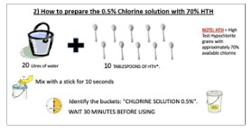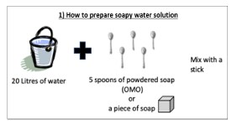

- Phase 3: Perform hand hygiene and put on PPE (at least 2 pp)
- Perform hand hygiene. Put on PPE according to WHO procedure (gloves, goggles or face shield, face mask, coveralls or gowns, apron, rubber boots). Heavy rubber gloves should be worn over latex/nitrile gloves. Ask the observer to review if there are breaches in the PPE

- Phase 4: Identify items disinfection area
  - Identify the area for collection of items to be disinfected outside the room.

- Phase 5: Remove contaminated waste
  - Movable items that require disinfection should be move outside the room.
  - A person inside the room carefully removes contaminated waste and put in the waste bag.
  - Carefully remove all the linen and put in the plastic bag.
  - Carefully transfer the bagged waste and linen to the outside bins.
  - Carefully inspect the inner part of the room for organic material (blood or body fluids, e.g. vomiting)
  - Remove all the excess of organic material by using absorbent paper, handling with care to avoid splashes and making unidirectional movement to not disperse the organic material
  - Clean and disinfect items placed outdoor.
- Step 1: Clean with soap and water
- Step 2: Disinfect with 0.5% chlorine
- Step 3: After contact time (10 mins), remove chlorine residue with clean water
- Take care with the oxygen cylinder to avoid accidents during the cleaning procedure. Do not use chlorine on the oxygen cylinder.

- Phase 6: Perform cleaning and disinfection (internal surfaces)
  - Start the cleaning of the internal room surfaces from the end to the front door and from the top to the bottom
- Step 1: Clean with soap and water
- Step 2: Disinfect with 0.5% chlorine
- Step 3: After contact time (10 mins), remove chlorine residue with clean water
- Ensure that all horizontal surfaces and all vertical surfaces are cleaned and disinfected, even if they don’t have visible soil.
- Once a cleaning cloth has contact with the surface, this should not be returned to the bucket to avoid contamination of the soap, water and disinfectant. In the event of limited availability of cloths, soak the cloth in water (this is the reason for a 4-bucket system).
- Cleaning cloths should be discarded into the waste bag whenever it becomes dirty.
- Content of the buckets should be discarded whenever they became dirty and replaced by a fresh one.

- Phase 7: Perform cleaning and disinfection (floor)
- Clean the ambulance floor, using the same unidirectional procedure, starting from the end of the room to the front door using separate buckets or newly prepared solutions
- Step 1: Clean with water + soap
- Step 2: Disinfect with 0.5% chlorine
- Step 3: After contact time (10 mins), remove chlorine residue with clean water
- Step 4: Let air dry Ensure that all horizontal surfaces and all vertical surfaces in the ambulance (windows, panel) are cleaned and disinfected, even if they don’t have visible soil.

- Phase 8: Perform cleaning and disinfection (External)
  - Clean thoroughly the external ambulance surface using separate buckets or newly prepared solutions
- Step 1: Clean with soap and water
- Step 2: Disinfect with 0.5% chlorine - The exterior of ambulance does not require a full disinfectant wipe down, except for the door handles
- Step 3: After contact time (10 mins), remove chlorine residue with clean water.
- Step 4: Let air dry
  - Allow the ambulance to be open and ventilated for about 10 to 20 minutes to minimize the odor of disinfectant

- Phase 9: Disposal of contaminated items
  - Discard the dirty cleaning cloth in the waste bag
  - Discard the removable pad of the mop in the waste bag
  - Disinfect the handling part of the mop OR floor squeegee and place outside the ambulance
  - Discard the remaining content of the buckets safely into a designated area
  - Move to the doffing area

- Phase 10: Removal of PPE
  - Remove the PPE in the doffing, according to the standard procedure.
  - An observer should supervise doffing to ensure the safety of the procedure.
  - Discard the PPE that is disposable on the waste bin/bag.
  - Remove boots and reusable aprons and place them in appropriate plastic bag/bin to send to PPE decontamination area.
  - Perform hand hygiene.

